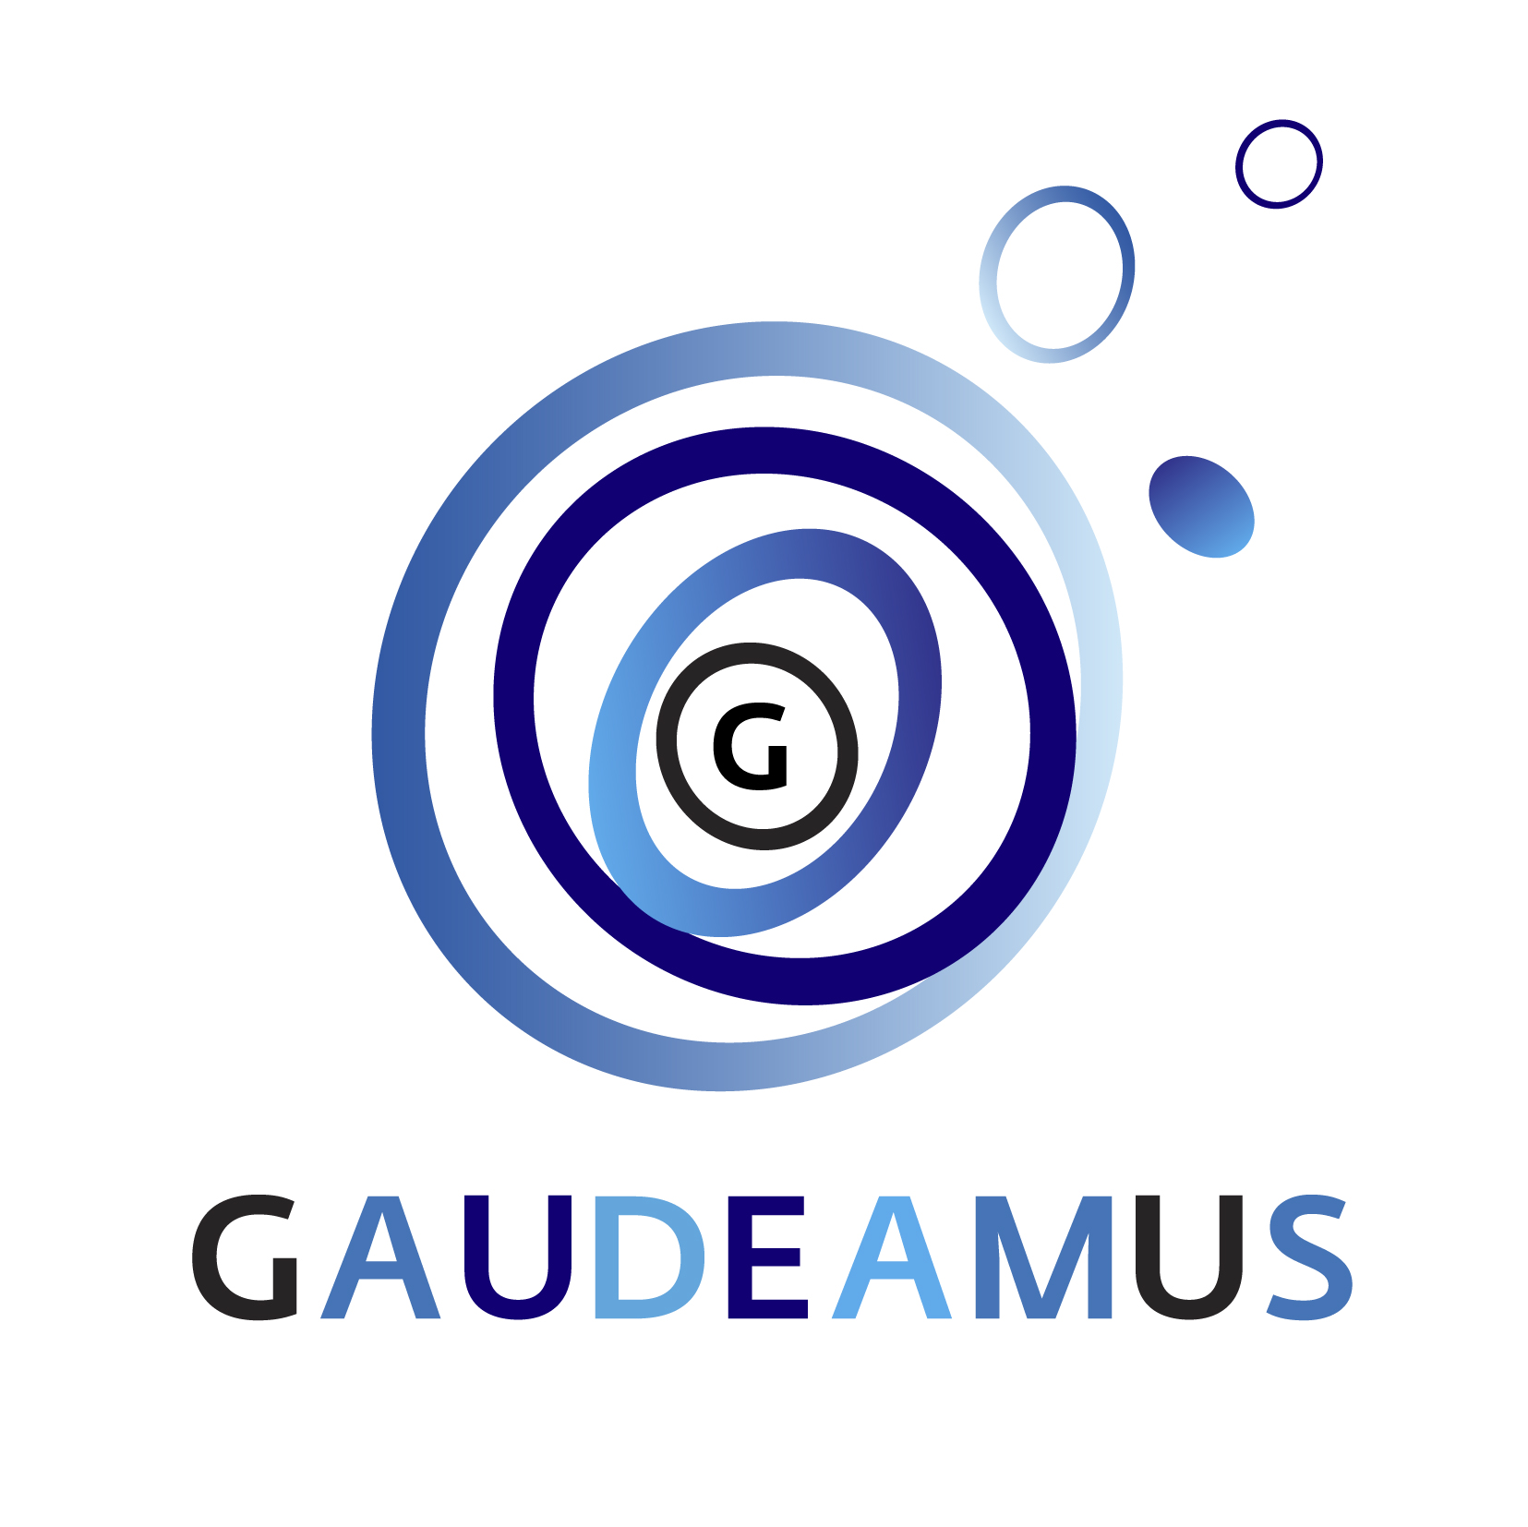

PRESS RELEASE Utrecht, 15 November 2017

SIX YOUNG MUSIC PIONEERS NOMINATED FOR GAUDEAMUS AWARD 2018

The nominations for the Gaudeamus Award 2018 are announced. Over 336 scores from 43 different countries have been thoroughly studied by an international jury. This year, six young music pioneers are selected for the prestigious composition award: William Kuo (1990, CAN), Sebastian Hilli (1990, FIN), Lawrence Dunn (1991, GBR), Raphael Languillat (1989, FRA), Matthias Krüger (1987, DEU) and William Dougherty (1988, USA). The Gaudeamus Award is a talent award for young composers under the age of 30.
Since the prize was first awarded in 1957, it has established itself internationally as a highly sought after and renowned award for young music pioneers.

During the annual Gaudeamus Music Week in September 2018, several works of the nominated music pioneers will be performed. The festival is a showcase for the six composers, where both the public and the international professional field get a broader view of them and their work. The jury guides the nominees during the rehearsal process and finally assesses the performances of all their pieces. At the end of the festival the jury selects the winner of the Gaudeamus Award. The professional jury consists of composers Nicole Lizee, Richard Ayres, Mayke Nas and Pierluigi Billone.

The Gaudeamus Award is regarded by composers as an international recognition of their work and as such functions as a springboard in the early career of a young music pioneer. Once nominated for the Gaudeamus Award, Gaudeamus continues to support the young composers: their works are repeated elsewhere, commissions for new compositions follow and composers are regularly asked to participate in festivals and co-productions with organizations worldwide. This way, Gaudeamus scouts young music pioneers, stimulates their development, and presents their music to an audience of curious music lovers.

History Gaudeamus Award
Louis Andriessen, Micha Mengelberg and Michel van der Aa were not a day older than 30 when they won the Gaudeamus Award. The internationally renowned prize for promising composers was first awarded in 1957 to 22-year-old Peter Schat. Each year since then, a professional jury selects the most talented composers under 30 from hundreds of submitted scores.
The Gaudeamus Award 2017 was awarded to the Dutch music pioneer Aart Strootman.

The Gaudeamus Music Week takes place from Wednesday 5th to Sunday September 9th 2018. More information and biographies of the nominees: gaudeamus.nl

---------------------------------------------------------------------------------------------------

